Understanding Dystopia
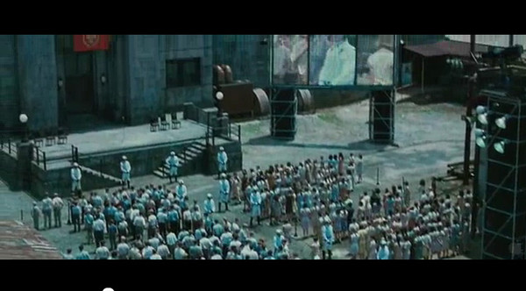

Utopia: A place, state, or condition that is ideally perfect in respect of politics, laws, customs, and conditions.
Dystopia: A futuristic, imagined universe in which oppressive societal control and the illusion of a perfect society are maintained through corporate, government, technological, moral, or totalitarian control. Dystopias, through an exaggerated worst-case scenario, make a criticism about a current trend, societal norm, or political system.

Characteristics of a Dystopian Society
- Propaganda is used to control the citizens of society.
- Information, independent thought, and freedom are restricted.
- A figurehead or concept is worshipped by the citizens of the society.
- Citizens are perceived to be under constant surveillance.
- Citizens have a fear of the outside world.
- Citizens live in a dehumanized state.
- The natural world is banished and distrusted.
- Citizens conform to uniform expectations. Individuality and dissent are bad.
- The society is an illusion of a perfect utopian world.

Types of Dystopian Controls
Most dystopian works present a world in which oppressive societal control and the illusion of a perfect society are maintained through one or more of the following types of controls:
• Corporate/Business control: One or more large corporations control society through products, advertising, and the media. Examples include Minority Report
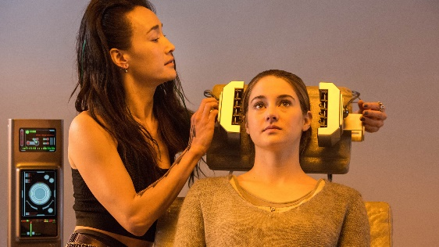
• Government control: Society is controlled by a government that has strict or impossible rules and regulations, and incompetent government officials. Example: The Hunger Games, Divergent

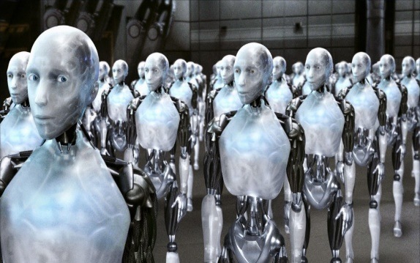
• Technological control: Society is controlled by technology—through computers, robots, and/or scientific means. Examples: The Matrix, The Terminator, and I, Robot.

• Philosophical/religious control: Society is controlled by philosophical or religious ideology often enforced through a dictatorship or theocratic government.

The Dystopian Protagonist
- Often feels trapped and is struggling to escape.
- Questions the existing social and political systems.
- Believes or feels that something is terribly wrong with the society in which he or she lives.
- Helps the audience recognizes the negative aspects of the dystopian world through his or her perspective.

