Chapter 2.1 Notes: The Land Between Two Rivers

Vocabulary
Scribe:
Fertile Crescent:
City-state:
Polytheism:
Myth:

The Land Between Two Rivers
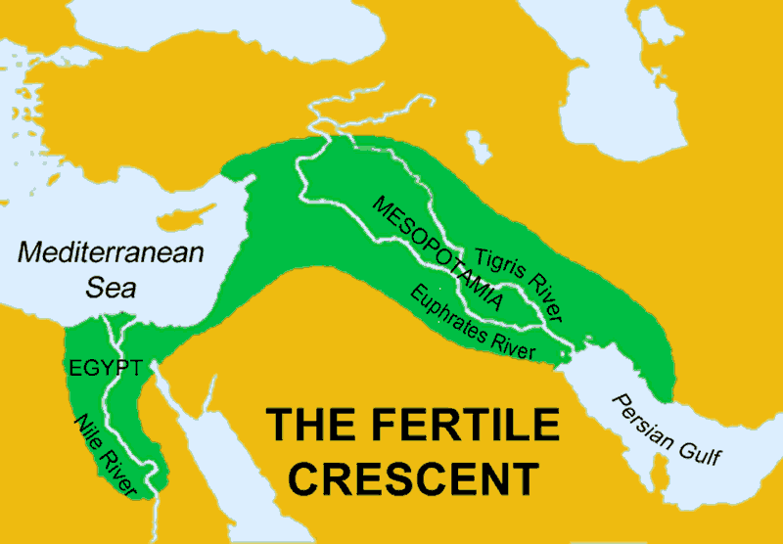
The first known schools were set up in the city of _____________ over ___________ years ago.

Sumerian schools taught boys and girls the new invention of ____________.

Graduates of the schools became ____________ or professional ___________.

Why were scribes important in Sumer?

The Geographic Setting
- Sumer is located in the region of _________________.
- Mesopotamia is a __________ word meaning ____________________.
- Mesopotamia is part of _______ _________________ ______________.

What geographical features made life in the Fertile Crescent possible?

Why do you think people continued to live in the Fertile Crescent despite the threat of floods?

Rivers of Life and Death
The two rivers that surrounded Mesopotamia are:

The benefits of these rivers include:

The downside of these rivers include:

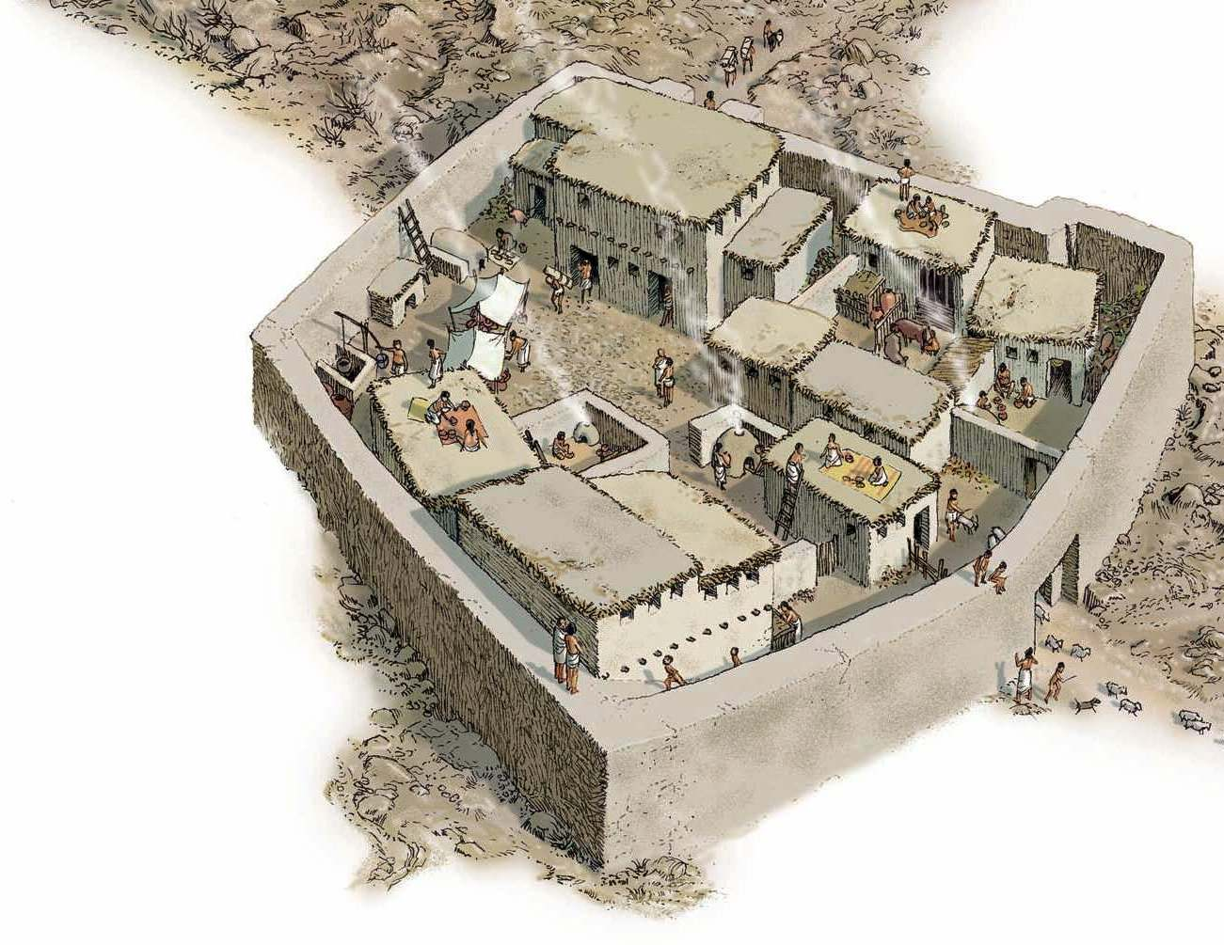
The First Cities
________ _______ encouraged the growth of cities.
List two things that cities in Sumer shared:

Sumerian cities did not have the same __________. Instead they ran as _______________.

Each city had their own ________________, ________________, _______________, and ________________.

In the space below, list some of the key features of a Sumerian city (what did the city look like?):

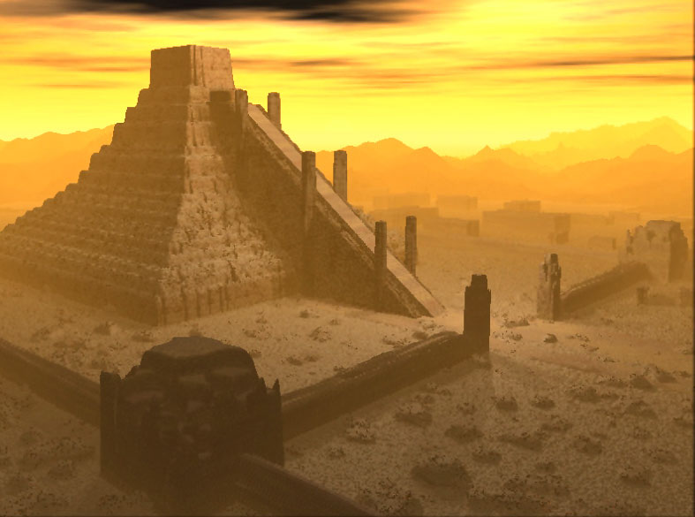
Sumerian Religion
Each city included a _________, or temple to the main______ or __________ of the city.

Activities that took place at temples include:

Some Ziggurats were more than ______________ high.

What did the Sumerians believe these temples were used for?

Sumerians worshipped __________. This is known as _____________.

How did the temple priests care for the statues of gods and goddesses?

The _________ beliefs of the Sumerians tell us:

___________ was also a way to express what was important to them.

The Fall of Sumer
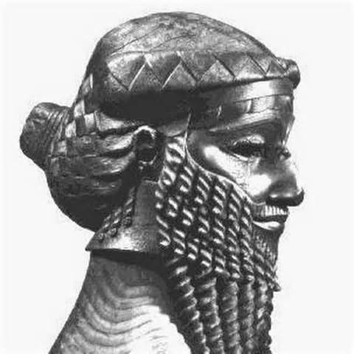
For Sumer, its __________ became its ______________.
Rulers fought over ______ and _______ use.
Around 2300 B.C. Sumer was conquered by ________. The ruler _______________ united the city-states.

He also improved Sumer’s:

For how long did the states stay united?

It fell to _____________ rival, Babylonia, in _________.

