Chapter 1.2: Prehistory
Directions: Complete this packet as you read Chapter 1, Section 2 on pages 16-23.

Vocabulary

Review the following terms before reading the section:

- Evidence: Something that serves to prove or disprove information.
- Ward-off: To turn away.
- Characterize: To describe the qualities of.
- Pastoral: Related to the raising of livestock

Define the following words after you read the section:
- Hominid:
- Stone Age:
- Nomad:
- Domesticate:

Reading Notes
After reading, fill in the missing details from the section. Look back into the text as you work.
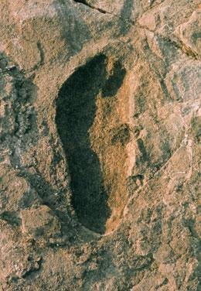
- About _____________ years ago, a huge explosion took place in ________________. A ____________ explosion followed by rain turned the volcano _______ into mud.

- In ________ scientists found _______________ preserved in the _________ that was left over from the volcano eruption.

- Footprints were identical to ________________________________.

- This evidence helped scientists understand ________________ ___________________.

- One million years after the footprints were made, early hominids began making _____________.

The Stone Age Culture
- Began with the creation of:

- The Stone age continued until:

- Scientists divide the Stone Age into ____ Periods (list and define each period):
  - 1.

  - 2.

  - 3.

- Almost all human history took place during:

Tools
- Tools were made out of:

- Tools allowed early humans to:

- Using advanced tools occurred during:

Hunters and Gatherers
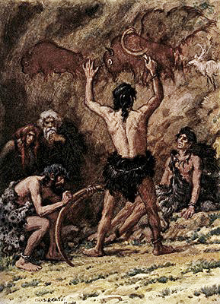
- Hunter-gathers lived in ___________.

- Food they ate included:

- _______ were responsible for hunting.

- Tools used for hunting:

- Hunting in ___________ worked best.

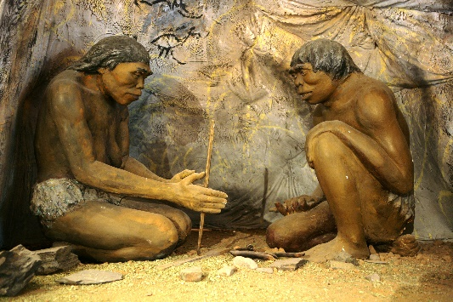
Use of Fire
- Learned how to use fire (when?):

- May have first learned about fire by:

- Used fire for protection by:

- Learned how to make fire by:

- Making fire allowed our ancestors to:

Settlements
- As early humans developed ________, they began to:

- Many hominids were _____________.

- Early hominids were living in _____________ and _______________ as early as _____________ years ago.

- Modern humans originated (when, where):

- Crossed from ________ to N. America (when):

Farming
- Began during:

- Began in:

- How farming was learned:

- What farming meant for people:

- ___________ were responsible for farming/planting.

- Features that make an area better for farming (list the feature and describe why it is important):

- Examples of first crops and where they were grown:

- How plants were domesticated:

Animals

- Pastoral nomads are:

- Domesticated animals were part of the ___________ Age.

- The first domesticated animals (why?):

- Larger domesticated animals (and why they were domesticated):

- The challenge of domestication:

