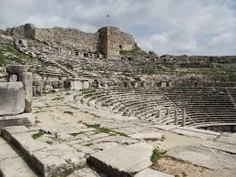
Chapter 1 Section 3: The Beginnings of Civilization

Directions: Before reading, preview the text headings and write down two questions you have about ancient civilizations. After reading, record your answers to those questions.
1.

2.

__________________________________________________
Vocabulary
Irrigation: supplying land with _____________ through a network of _______________.
Surplus: ________________________ than is ______________________.
Artisan: A _________________ who is especially ____________ in crafting items by _____________.
Civilization: A _______________ with _______________, central _____________, _______________ specializations, and _____________ classes.
Social Class: A group of ___________ with similar ___________, incomes, and ways of ___________.

__________________________________________________

____________ techniques were important in creating ________ _____________.
Irrigation is:

Advantages of a Settled Life
___________ was harder work than _________________________. Yet, it had _________ rewards.
People who produced their own food could:

People no longer had to:

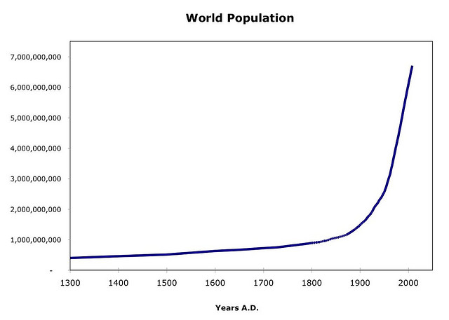
There was often a surplus in food. Surplus means:

Population Grows
How did surplus impact population growth?

Scientists estimated that 10, 000 years ago, the population was ________________.

People settled into farming life _____________________ years ago. The world population rose from 5 million to ____________________.

By what date had the population reached more than 6 billion?

How would you describe the rate of population growth before the year A.D. 1?

Early Villages and Towns
People lived in the New Stone Age ____________________ settlements for many centuries.
Food surpluses meant that people:

The Growth of Cities
Cities were more likely to develop in areas where:

People needed a source of __________________ and materials to build _____________________.

The earliest cities grew along ______________________ because the soil is __________________.

The Earliest Cities
City | Present-Day Location | Date Founded | Where were the cities of Ur and Anyang located, and founded?  What geographic features do you think these two cities had in common?
Ur | Iraq | c. 3500 B.C.
Memphis | Egypt | c. 3100 B.C.
Mohenjo-Daro | Pakistan | c. 2700 B.C.
Knossos | Greece | c. 2500 B.C.
Anyang | China | c. 1700 B.C.

What made cities different from villages?
- Population Size: _____________________________________________________
- Structures: _________________________________________________________
- Occupaiotns: ________________________________________________________

Governments Form
As ___________________ grew, _____________ formed.
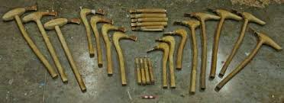
The purpose of governments were to:

The Bronze Age
In 6600 B.C. artisans in Europe and Asia learned:

By 3000 B.C., artisans mixed copper with ____________________ and made __________________.

How was bronze different than copper?

Trade and the Spread of Ideas
What did traders take to faraway cities? What did they get in return?

By 3500 B.C. some civilizations had developed _____________________ and ________________.
How did this invention affect trade?
How did trade affect society?

Social Classes Develop:
Trade led to prosperity, and prosperity led to the development of ____________________________.

Free People

