Section 1 Notes: Geography and History
Directions: Complete the following notes and questions as you read Chapter 1, Section 1 on pages 10-15.
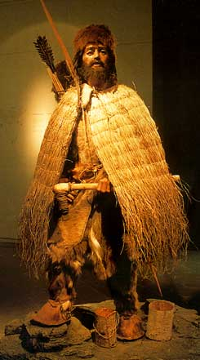
In ________ the ___________ was found in the by two hikers on the boarder of ____________. Scientists discovered that he has lived over 5000 years ago, in __________. His _______________, _____________, and ____________ were well preserved. Scientists used this information to understand his life. At first, Scientists thought the Iceman __________ to death.

- What was the most important clue about the Iceman’s life? Why?

- Why did scientists change their mind about the Iceman’s cause of death?

Understanding History
- About 5000 years ago, peoples in _____________ and ____________ developed a system of ______________. They began keeping written records of ___________. This marked the beginning of __________.

Prehistory is ___________________________________________.
- ______________ are scientists who examine objects to learn about past peoples and cultures. They search for ___________, _____________, and ____________ to tell them about how people lived.
- What is one example of a tool archeologists have found in prehistoric camps?

- What do these tools tell archeologists?

Written History
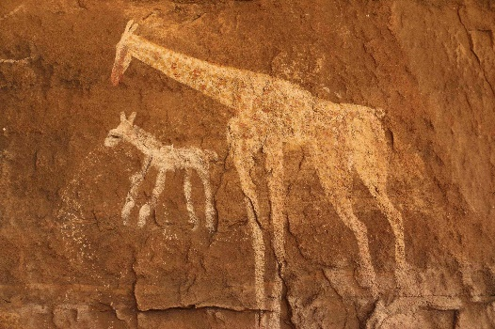
Written records help historians understand a __________, including ________, _________, and __________. Historians also look at what ___________ living at the same time _________ about that society.

Oral History
- ________________ are stories passed down by word of mouth. These stories can include _________ history, but also tell stories about _________ or events in the past.

- Like myths and legends, they often contain _________ mixed with _________.
- A professional storyteller in West Africa is called a _____________.

1. Why are historians interested in oral traditions?

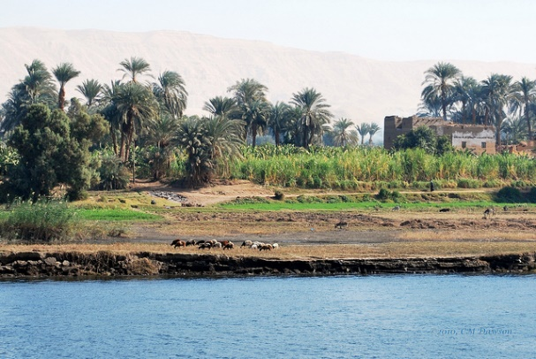
Linking Geography and History
- Geography is __________________ _____________________________.

- Knowing the connection between geography and ___________ is key to understanding _____________.

- ______________, __________________, and _______________ of a place all impact the lives of people who live there.

- Why did the ancient Egyptians develop a successful civilization?

How to Use a Timeline
The four steps of using a timeline are:

Vocabulary
Directions: Based on the reading, match the following vocabulary words with the correct definition.
____ 1. Community To place on or put into
___ 2. Curiosity Something written down to preserve knowledge
___ 3. Record The desire to learn
___ 4. Deposit A group of people living in the same area

Big Question: How did physical geography affect the growth of civilizations?

